Corresponding Angles
# Source: AI Source: Provided by: [Data Path: Persons Table -> ID Column: 1, Name_En Column: Motasem Essam] -> From: [ChatGPT] on [7/25/2026]
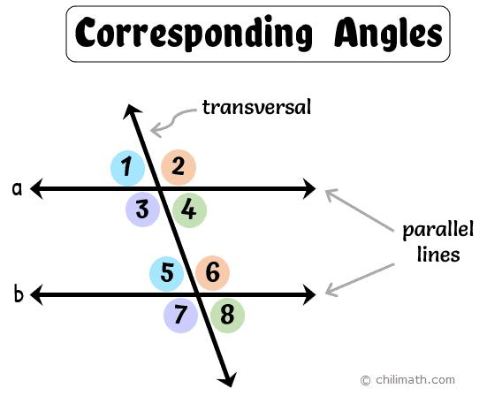
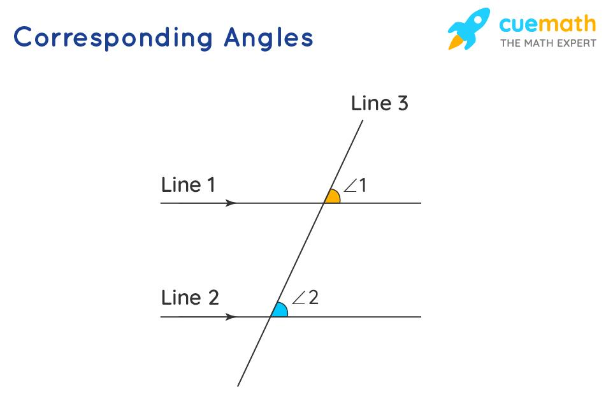
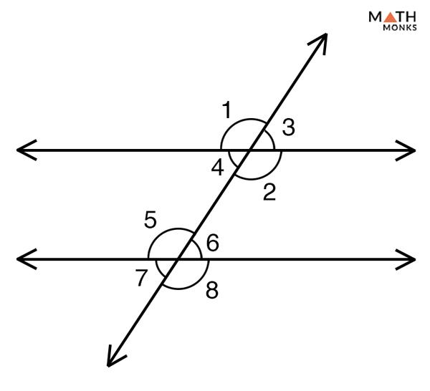
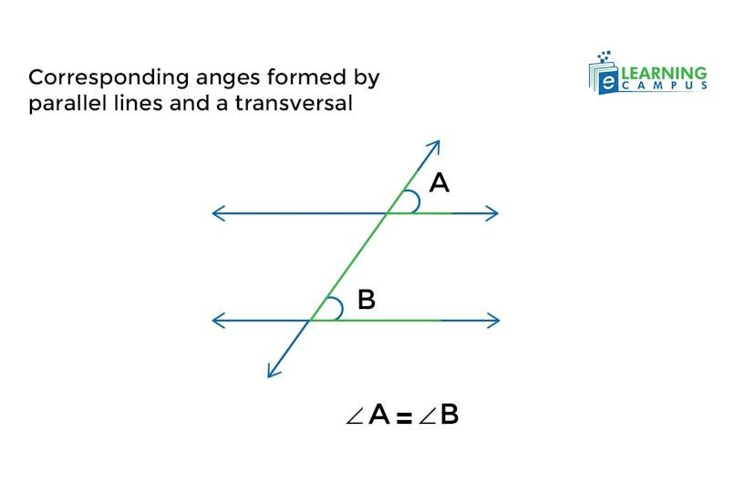
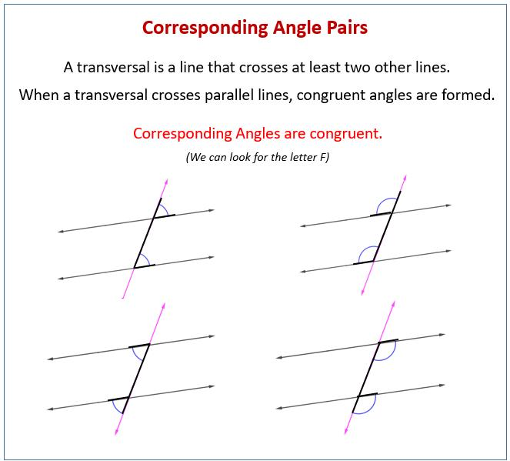
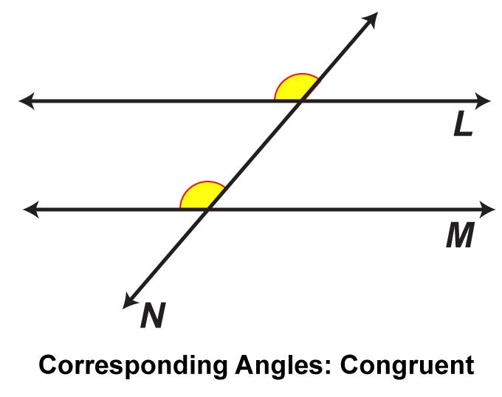

Definition
# Source: AI Source: Provided by: [Data Path: Persons Table -> ID Column: 1, Name_En Column: Motasem Essam] -> From: [ChatGPT] on [7/25/2026]
Corresponding Angles are pairs of angles that occupy the same relative position when a transversal crosses two lines.
When a transversal intersects two parallel lines, corresponding angles are equal in measure (congruent).

Characteristics
# Source: AI Source: Provided by: [Data Path: Persons Table -> ID Column: 1, Name_En Column: Motasem Essam] -> From: [ChatGPT] on [7/25/2026]
Corresponding angles:
- Are formed when a transversal crosses two lines.
- Have the same relative position at each intersection.
- One angle is at the first intersection.
- The other angle is at the second intersection.
- Are usually located on the same side of the transversal.
- Are both:
  - Interior or exterior in matching positions.
  - On the same side of the transversal.

Illustration
# Source: AI Source: Provided by: [Data Path: Persons Table -> ID Column: 1, Name_En Column: Motasem Essam] -> From: [ChatGPT] on [7/25/2026]
Two Parallel Lines Cut by a Transversal
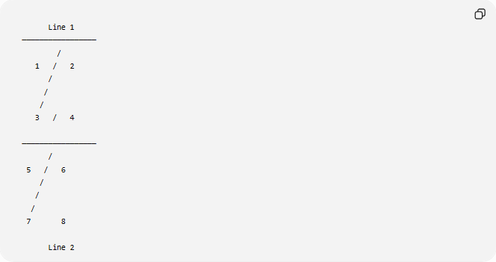

Line 1
─────────────────
/
1 / 2
/
/
/
3 / 4

─────────────────
/
5 / 6
/
/
/
7 8

Line 2
The corresponding angle pairs are:
$$∠1\text{ and }∠5 \\ ∠2\text{ and }∠6 \\ ∠3\text{ and }∠7 \\ ∠4\text{ and }∠8$$

Corresponding Angles Theorem
# Source: AI Source: Provided by: [Data Path: Persons Table -> ID Column: 1, Name_En Column: Motasem Essam] -> From: [ChatGPT] on [7/25/2026]
Theorem
When a transversal crosses two parallel lines, corresponding angles are congruent.
If:
$$l_{1}∥l_{2}$$
then:
$$∠1≅∠5 \\ ∠2≅∠6 \\ ∠3≅∠7 \\ ∠4≅∠8$$

Mathematical Representation
# Source: AI Source: Provided by: [Data Path: Persons Table -> ID Column: 1, Name_En Column: Motasem Essam] -> From: [ChatGPT] on [7/25/2026]
For parallel lines:
$$m∠1=m∠5 \\ m∠2=m∠6 \\ m∠3=m∠7 \\ m∠4=m∠8$$

Example
# Source: AI Source: Provided by: [Data Path: Persons Table -> ID Column: 1, Name_En Column: Motasem Essam] -> From: [ChatGPT] on [7/25/2026]
Given:
$$m∠1={65}^{∘}$$
Find:
$$m∠5$$
Because they are corresponding angles:
$$m∠5=m∠1$$
Therefore:
$$m∠5={65}^{∘}$$

Finding Unknown Angles
# Source: AI Source: Provided by: [Data Path: Persons Table -> ID Column: 1, Name_En Column: Motasem Essam] -> From: [ChatGPT] on [7/25/2026]
Example:
Two corresponding angles are:
$${\left(3x+10\right)}^{∘}$$
and
$${\left(5x-50\right)}^{∘}$$
Because they are corresponding:
$$3x+10=5x-50$$
Solve:
$$60=2x$$
$$x=30$$
Angle measure:
$$3\left(30\right)+10={100}^{∘}$$
Therefore:
$$∠1=∠5={100}^{∘}$$

Corresponding Angles in Parallel Lines
# Source: AI Source: Provided by: [Data Path: Persons Table -> ID Column: 1, Name_En Column: Motasem Essam] -> From: [ChatGPT] on [7/25/2026]
When two parallel lines are crossed by a transversal:
- Corresponding angles are equal.
- Alternate interior angles are equal.
- Alternate exterior angles are equal.
- Same-side interior angles are supplementary.

Corresponding Angle Positions
# Source: AI Source: Provided by: [Data Path: Persons Table -> ID Column: 1, Name_En Column: Motasem Essam] -> From: [ChatGPT] on [7/25/2026]
There are four possible matching positions:
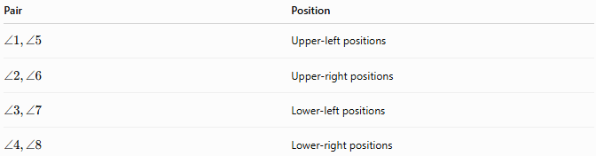
Pair | Position
$$∠1,∠5$$ | Upper-left positions
$$∠2,∠6$$ | Upper-right positions
$$∠3,∠7$$ | Lower-left positions
$$∠4,∠8$$ | Lower-right positions

Real-World Examples
# Source: AI Source: Provided by: [Data Path: Persons Table -> ID Column: 1, Name_En Column: Motasem Essam] -> From: [ChatGPT] on [7/25/2026]
Corresponding angles appear in:
- Railroad tracks crossed by a road.
- Building structures with parallel beams.
- Floor patterns.
- Window designs.
- Bridges.
- Engineering drawings.
- Architectural plans.

Applications
# Source: AI Source: Provided by: [Data Path: Persons Table -> ID Column: 1, Name_En Column: Motasem Essam] -> From: [ChatGPT] on [7/25/2026]
Corresponding angles are used in:
- Plane Geometry
- Coordinate Geometry
- Parallel Line Problems
- Trigonometry
- Engineering
- Architecture
- Construction
- Surveying
- CAD (Computer-Aided Design)
- Technical Drawing

Advantages
# Source: AI Source: Provided by: [Data Path: Persons Table -> ID Column: 1, Name_En Column: Motasem Essam] -> From: [ChatGPT] on [7/25/2026]
Studying corresponding angles helps to:
- Find unknown angles quickly.
- Prove lines are parallel.
- Solve geometry problems.
- Understand transversal relationships.
- Analyze parallel structures.

Limitations
# Source: AI Source: Provided by: [Data Path: Persons Table -> ID Column: 1, Name_En Column: Motasem Essam] -> From: [ChatGPT] on [7/25/2026]
Corresponding angles are only guaranteed to be equal when:
- The two lines are parallel.
- A transversal intersects both lines.
If the lines are not parallel, corresponding angles may not be equal.

Comparison with Other Angle Relationships
# Source: AI Source: Provided by: [Data Path: Persons Table -> ID Column: 1, Name_En Column: Motasem Essam] -> From: [ChatGPT] on [7/25/2026]
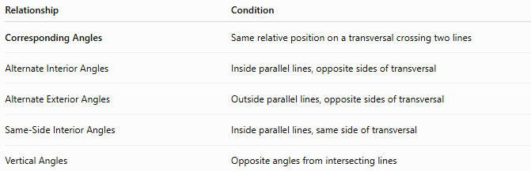
Relationship | Condition
Corresponding Angles | Same relative position on a transversal crossing two lines
Alternate Interior Angles | Inside parallel lines, opposite sides of transversal
Alternate Exterior Angles | Outside parallel lines, opposite sides of transversal
Same-Side Interior Angles | Inside parallel lines, same side of transversal
Vertical Angles | Opposite angles from intersecting lines

Key Points
# Source: AI Source: Provided by: [Data Path: Persons Table -> ID Column: 1, Name_En Column: Motasem Essam] -> From: [ChatGPT] on [7/25/2026]
- Corresponding Angles have the same relative position at two intersections.
- They are formed by a transversal crossing two lines.
- If the lines are parallel:
$$m∠A=m∠B$$
- They are used to identify parallel lines and solve angle problems.

Conclusion
# Source: AI Source: Provided by: [Data Path: Persons Table -> ID Column: 1, Name_En Column: Motasem Essam] -> From: [ChatGPT] on [7/25/2026]
Corresponding Angles are angle pairs created when a transversal intersects two lines. They occupy matching positions at the two intersections. When the crossed lines are parallel, corresponding angles are always congruent (equal in measure). They are fundamental in plane geometry, coordinate geometry, engineering, architecture, construction, surveying, CAD, and technical drawing, where they help analyze parallel structures, determine unknown angles, and prove geometric relationships.

